

North Walls Community School Nursery

Early Learning & Childcare Setting

Handbook 2020-2021

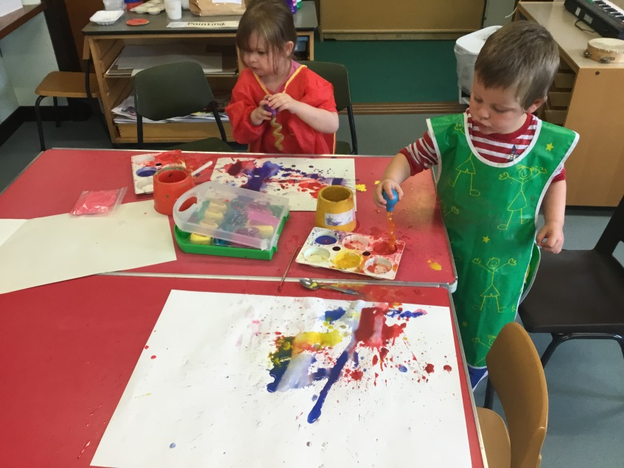

**‘Believe to Achieve’**

Introduction

Welcome to North Walls Early Learning and Child Care

North Walls Nursery is situated within the school. It is a bright, spacious room with areas for messy play, investigation, exploration and role play. There are quiet spaces for reading and resting .Outside is a well-equipped playground and school grounds. The school hall is used for dinner and keeping active when the weather is just too poor for going outside!

The nursery class works in partnership with parents in developing children’s learning. The Early Years staff encourage parents to become involved in the nursery setting. We value any comments or suggestions you may have, so please feel free to speak to staff when you arrive or when you collect your child.

This is a brief description of activities in the nursery and what your child will need. Please don’t hesitate to contact a member of staff if you have any questions.

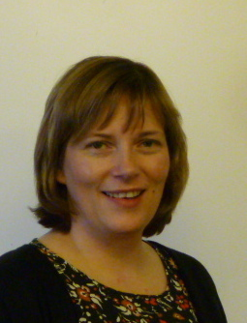 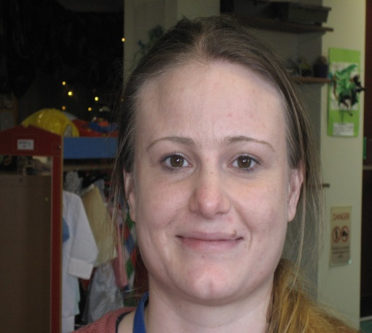 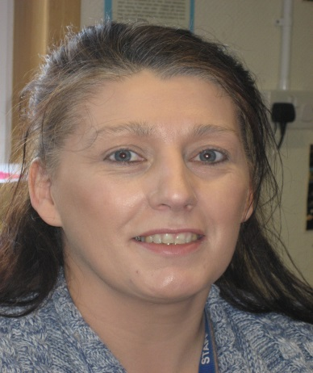

Ms Shirley Stuart

Head Teacher

Mrs Liz Train

Lead Early Years Practitioner

Mrs Claire Thomson

Lead Early Years Practitioner

Address: North Walls Community School

Lyness

Orkney

KW16 3NX

Telephone: 01856 791 246

Email: admin.northwalls@glow.orkneyschools.org.uk

**Local Authority**:

Director of Education, Leisure & Housing Mr James Wylie

Head of Schools Mr Peter Diamond

Principle Teacher Early Years Mrs Catherine Diamond

**Parent Council:**

Chairperson Mrs Rachel Thomson

Sessions and times

North Walls Nursery offers up to 1140 hours of childcare per year for 3 and 4 year olds and to eligible 2 year olds. This equates to 30 hours per week during the school term. Details of the school term dates can be found in the school handbook and on the Orkney Islands Council website. For information on eligibility please contact the school or Catherine Diamond at Orkney Islands Council.

**The opening times are:-**

Monday, Tuesday, Wednesday, Thursday: 9:15 am - 3:35 pm

Friday: 9:15 am - 2:00 pm

Please come into the nursery when you drop your child off and again when you collect your child. It’s always good for the children to show you what they’ve been doing and this also gives you a chance to chat informally with staff. **Covid-19 update: please just come to the nursery door with your child to drop off and collect. Please also remember to wear a face mask and keep to the 2m distancing with other children and adults.**

Day to day information

**Clothing:**

We do lots of messy activities and although aprons are provided, sometimes clothes get paint, baking mix etc. on them so please send your child to nursery with everyday clothes on. It is helpful if you can leave a spare set of clothing for your child in a bag so they can change into their own clothes if needed. Your child will also need a pair of indoor shoes that can be left at nursery.

Clothes that your child can put on and take off themselves are best as this helps encourage independence although support will be given if needed. Please regularly check your child’s shoes are well fitting and don’t slip off as we do lots of running, jumping, hopping and balancing!

We go outside in lots of different weathers so always please ensure your child has appropriate clothing on. The school provides waterproofs and wellies for outdoor activities.

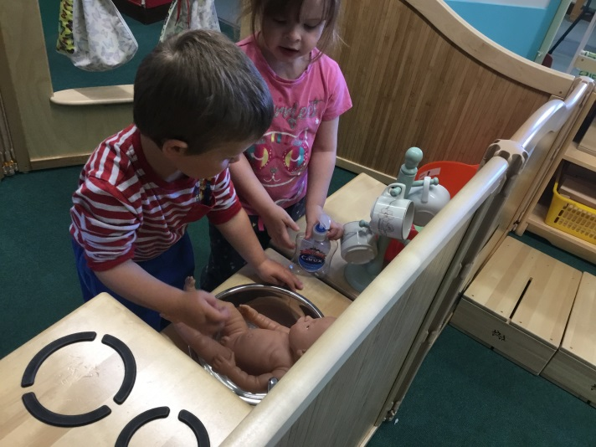

**Snacks:**

Snacks are provided in accordance with ‘Setting the Table’, the nutritional guidance and food standards for early years providers in Scotland.

All staff have a Basic Food Hygiene certificate and follow procedures accordingly.

The children are encouraged to help in the preparation of snacks, which promotes their understanding of healthy choices, hygiene, preparation of food and social skills. The snacks are varied and nutritious - for example fruit, yogurt, raw vegetables, bread, crackers etc.

Children have the choice of milk or water during snack time.

Snack money is 50p per session and should be paid weekly (£2.50 for a full week).

**Toothbrushing:**

We follow the NHS Childsmile toothbrushing programme and each child is encouraged to brush their teeth after snack with the supervision of a member of staff. They each have their own toothbrush and we follow strict hygiene procedures throughout. **Covid-19 update: no toothbrushing in nursery currently.**

**School Meals:**

Nursery pupils join the school pupils in the hall for dinner, along with the Early Years staff and school staff. The meals are prepared in-house by our cook. School meals for nursery pupils are free. Please reply to the email from the kitchen weekly with your child’s meal choices. Pupils may bring a packed lunch to eat instead of a school meal.

**Library:**

Books and toys can be borrowed from the nursery. The Mobile Library van calls at the school every two months. We encourage parents/carers to help their child choose a book to share at home.

**Parent information board:**

This is situated at the nursery entrance and relevant information is displayed here, such as newsletters, menus and policies.

Typical nursery day

The Early Years staff always try to respond to the children’s needs and interests - as well as the Orkney weather - so it may mean that timings and activities may differ slightly from day to day. A typical day in nursery may be as follows;

**Children arrive** **with parents** – **9.15 am**. This gives staff and parents an opportunity to share information. Please park at the rear of the school in the car park outside the Healthy Living Centre and enter through the nursery door.

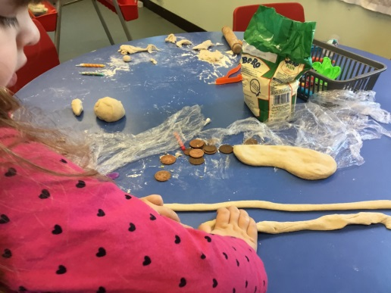**Hello Time** – this is where we share our news and look at all the areas and activities to choose from and plan what we are going to do for the day. We also decide what we will have for snack and what there is for dinner.

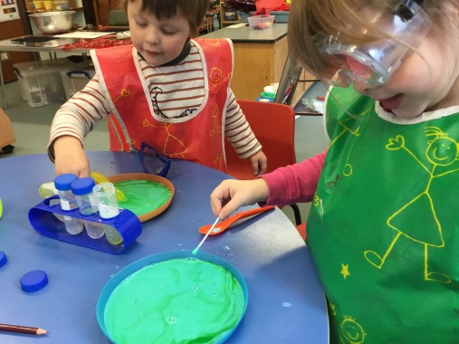**Group Time** – this part of the session is where the Early Years staff introduce an experience, activity or material to the children. This may be puppets, storytelling, language and maths games, music, sewing, rhymes, jigsaws, playdough. We might play ball games, dance, sing, have music time or a story with rhymes and songs.

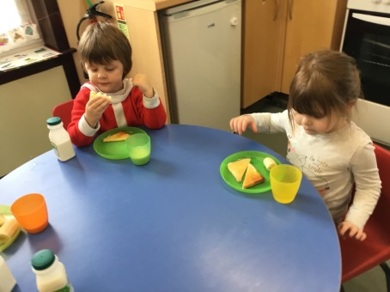**Snack time – 10.15 am approximately.** At snack time the children select their own cup, plate etc and sit at the table. Children have the opportunity to peel and chop fruit and veg. Milk and water are available. Pouring and spreading independently is encouraged.

**Tooth brushing** - after snack. **Covid-19 update: no toothbrushing in nursery currently.**

**Choosing Time** – This is the biggest part of our day; children now have time to invent, explore and create within the nursery. The range of activities includes painting, writing table, sand and water, bricks, playing games, counting and sorting, role play & house area, construction area and book area. Play may be indoors or outdoors. We use our outdoor area, the football pitch and tennis court to offer a variety of experiences such as climbing, running, riding trikes, kicking, throwing and catching balls.

At the end of choosing time, we all tidy up together.

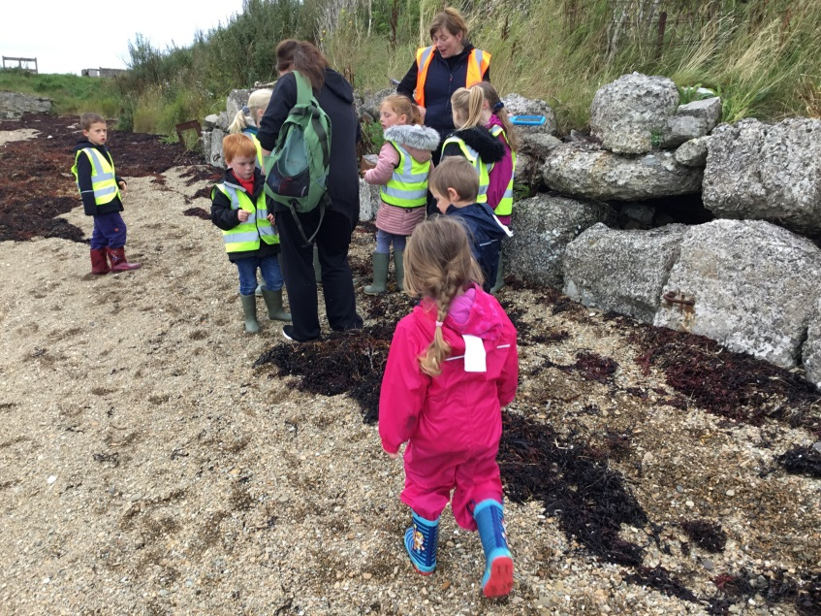 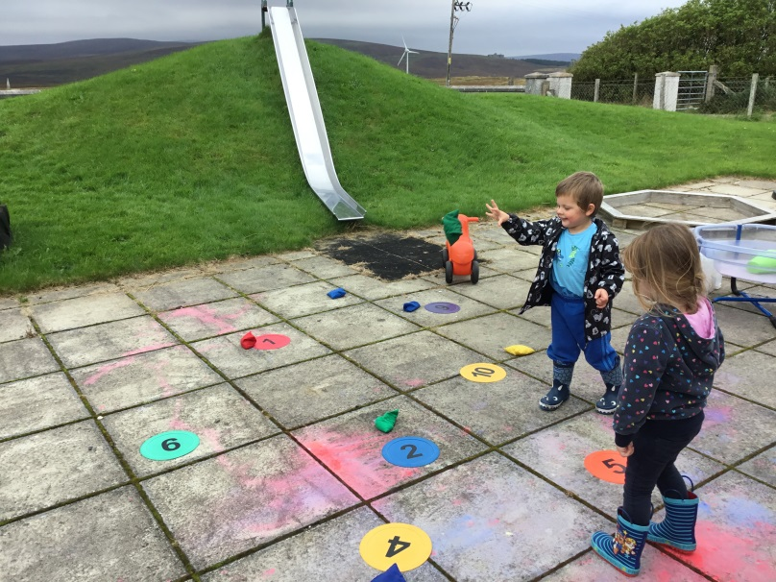

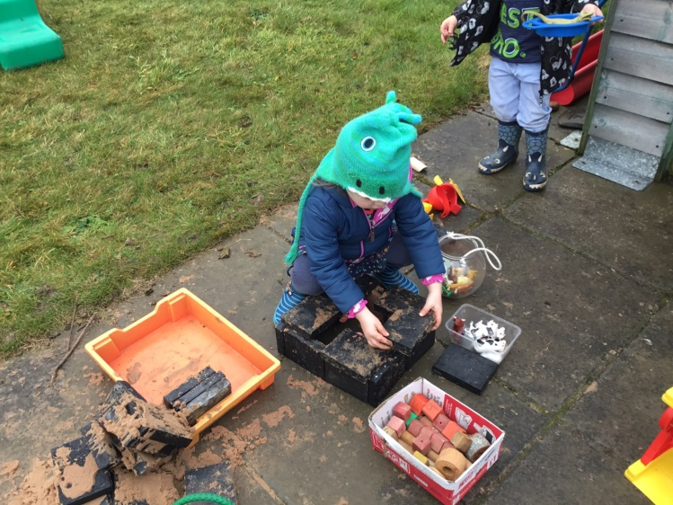 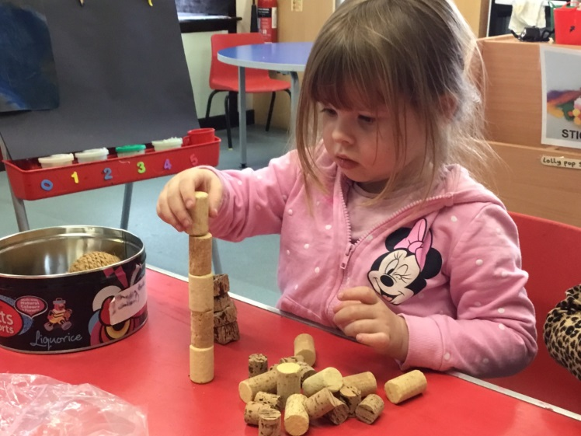

**Dinner Time –** **12.20 pm**. All pupils eat together in the school hall. Early Years staff sit with the nursery children and support them at dinner.

**Home Time** – **3.35 pm (2.00 pm on Friday).** When you collect your child this is an opportunity to talk with Early Years staff, have a look around and share any achievements or concerns. **Covid-19 update: please just come to the nursery door with your child to drop off and collect. Please also remember to wear a face mask and keep to the 2m distancing with other children and adults.**

Learning Folders

Each child will have a ‘Learning Journey’ folder. The aim of the learning folder is to build up a picture of your child, their interests, development and to share this with the child themselves, family and those who are important to the child. We aim to do this in a number of ways; encouraging children to contribute their work to the folder, learning stories (an observation of your child done by a member of staff), small notes (highlights of a child’s moment of achievement, wonder, excitement and so forth) and of course exciting moments from home, holidays, trips. We would love you to feel part of this process, you can take the folder home to share with family, take in pictures, photos from home or email photos to a staff member should this be more manageable (please remember to return the folder as this is an important document of your child’s progress)

Parental Involvement

Staff work in partnership with parents and encourage involvement as much as possible. Throughout the year parents and staff will have opportunities to share and exchange information about their child’s progress. This happens day to day and at parents’ meetings. Having parents’ meetings and time within the nursery are really important as it gives us a chance to have time to sit down and talk about your child’s progress or any worries you may have, as well as giving your child a chance to show off their nursery. *Don’t let any concerns build up; we can arrange a time for a chat*.

**Participation Policy:**

The school values input from parents regarding assessing and improving all parts of our service. If you have particular issues you would like to discuss please contact Early Years staff or the Head Teacher either directly or through the school office. In addition, parents may be asked by the school or other stakeholders to fill in questionnaires about the service we provide. We encourage you to fill these questionnaires in as a means of improving the service we provide.

Early Years Curriculum

The Curriculum for Excellence is the National Curriculum for children aged 3-18. It provides curricular areas and clearly defines what we anticipate children to learn as they develop (see below). We use this to plan learning experiences for the children. The Early Level Curriculum starts in Nursery and continues into Primary 1 giving continuity and progression for children as they transition into their first year of school.

**Health and Wellbeing Languages & Literacy**

**Numeracy and Maths Sciences**

**Social Studies Expressive Arts**

**Technologies Religious and Moral education**

The purpose of the Curriculum is to help children to become:

* **Successful learners**: through using their imagination and creativity, tackling new experiences and learning from them and developing important skills including literacy and numeracy through exploring and investigating while following their own interests.
* **Confident individuals**: through succeeding in their activities, having the satisfaction of a task accomplished, learning about bouncing back from setbacks, and dealing safely with risk.
* **Responsible citizens**: through encountering different ways of seeing the world, learning to share, give and take, learning to respect themselves and others, and taking part in making decisions.
* **Effective contributors**: through playing together in leading or supporting roles, tackling problems, extending communication skills, taking part in sustained talking and thinking, and respecting the opinions of others.

These are often referred to as ‘The Four Capacities’.

**Principles of Curriculum Design:**

There are seven broad principles that practitioners should take into consideration when planning children’s learning:

* Challenge and enjoyment in learning
* Breadth of learning
* Progression in learning
* Depth of learning
* Personalisation and choice e.g. in how to present learning
* Coherence (with other areas of learning)
* Relevance of learning

The starting point for planning is the children’s interest. There will always be adult planned activities, children-led activities and spontaneous activities.

If you have any queries about the curriculum or would like more information please talk to us or follow the curriculum link:

<http://www.educationscotland.gov.uk/learningandteaching/earlylearningandchildcare/index.asp>

Vision, Values and Aims

At North Walls every child matters. We aim to create a happy, healthy, safe, secure and nurturing learning environment where every child is included. We encourage all children to become independent, lifelong learners and achieve their full potential. We positively promote caring attitudes, respect and responsibility towards each other, the environment and the wider community.

The foundations for achieving this vision lie within our pupil constructed SMART **Values**:

**Safety & Happiness**

**Mindful Learners**

**Achievement for All**

**Responsibility & Resilience**

**Teamwork &Trust**

Our aim is to provide consistently high quality learning experiences, value the learning and achievements of all our children and promote high expectations and ambition to enable them to achieve their potential. We aim to support our pupils to develop the knowledge, skills and attributes they will need to do well in life, in learning and in the work place.

We aim to provide a **nurturing and trusting** environment in which everyone feels **safe, included** and **happy**.

We aim to support everyone to **achieve** their potential and be the best they can be.

We aim to encourage **active**, **healthy** lifestyles

We aim to encourage our learners to be **mindful** and **resilient.**

We aim to promote **respect** and **responsibility** so everyone’s rights are met.

Through **teamwork** and communication between staff, parents and pupils we aim to develop positive relationships amongst all members of the school community.

Health and Safety

It is important to let us know if your child has an allergy to any food or material or suffers from any medical conditions. You will be asked to complete a form when your child enters nursery and any medical details need to be included and discussed. If your child needs to take any medication, please let staff know and we will ask you to fill in a form to ensure it is administered correctly.

We ask for emergency contact numbers for parents and a relative or friend, whom we can contact if the parent is not available. If your child is not well please keep them at home until they are better. Children who have been absent with sickness / diarrhoea should remain off school for 48 hours after the last period of illness.

If your child is not well and not attending nursery for this or any other reason, please contact the school by 9.30 am.

Please let us know about any changes of address or telephone number, emergency contact details or home circumstances that could affect your child or concerns you may have about your child.

All our policies are available to parents – please speak to the Early Years staff.

Concerns and Complaints

For your child’s happiness, we believe it is important that any concerns or complaints you have are followed up as soon as possible.

The Early Years staff are always available for you to talk to at the beginning and end of each session. If you have any concerns or worries at all, please share these with us so that we can address them as soon as possible.

If there is something that needs more time to discuss then we can arrange a quieter time to meet.

Whether it is a suggestion, praise or a complaint, we hope you will feel able to talk with the staff or with the Head Teacher. If the Head Teacher is not available at the time, please make an appointment by calling in at the school office or phoning the school.

If you are not satisfied with the outcome of discussions with staff then you can contact the Head of Schools at Orkney Islands Council. If you wish to make a formal complaint to the Care Inspectorate, you can access the necessary information at:

<http://www.careinspectorate.com/index.php/complaints>

The most recent Care Inspectorate report can be accessed by visiting:

<https://www.careinspectorate.com/>