Week commencing 22nd August, 18th September, 30th October, 27th November, 2023 (8th January 2024)
WEEK1 | Monday | Tuesday | Wednesday | Thursday | Friday
Option one | Spaghetti Bolognese | Orkney mild chicken curry served with rice and naan bread | BBQ pulled pork served in a roll with Mediterranean style cous cous | Fish and chips, peas, and seasonal vegetables (ketchup available) | Toad in the hole served with gravy, tatties, seasonal vegetables
Information | Our Bolognese is boosted with hidden vegetables | Chicken can be served plain | Pork can be served plain | Fantastic Orkney fish from Orkney Fisherman’s Society | Sausages can be served separately
Option two | Roasted vegetable and bean pasta with seasonal vegetables | Homemade chickpea curry served with rice and naan bread. | Cheese and tomato pizza with cous cous, seasonal salad | Fishless fingers with chips, peas. | Quorn sausage toad in the hole served with gravy, tatties, seasonal vegetables
Information | All meals are served with a salad bar and Whole meal bread | Chickpeas are a fantastic source of protein | All meals are served with a salad bar and Whole meal bread | All meals are served with a salad bar and Whole meal bread | All meals are served with a salad bar and Whole meal bread
Option three | Homemade soup of the day.  Ham baguette | Homemade soup of the day. Orkney cheese roll | Homemade soup of the day. Baked tattie with Orkney mince | Homemade soup of the day served, poached salmon salad | Homemade soup of the day. Chicken mayonnaise wrap
Information | Sandwiches, rolls, wraps, baguettes come with soup and yoghurt / pudding | Sandwiches, rolls, wraps, baguettes come with soup and yoghurt / pudding | We always try and source Orkney tatties | You can have ham or cheese or both today | Sandwiches, rolls, wraps, baguettes come with soup and yoghurt / pudding
Pudding | Golden acre yoghurt (various) or chocolate brownie | Golden acre yoghurt (various) | Golden acre yoghurt (various) | Golden acre yoghurt (various) | Golden acre yoghurt (various) or Ice cream
Information | We make this brownie using veg power and reduced sugar | A great source of calcium and less than 10g sugar | Various flavors to choose from | A great form of calcium with a freshly made low sugar berry sauce | Packed full of calcium
Fruit | Always available for all pupils additional to pudding | Always available for all pupils additional to pudding | Always available for all pupils additional to pudding | Always available for all pupils additional to pudding | Always available for all pupils additional to pudding
Medical Diet - if you have any medically certified dietary requirements, please contact the Head cook or School Admin
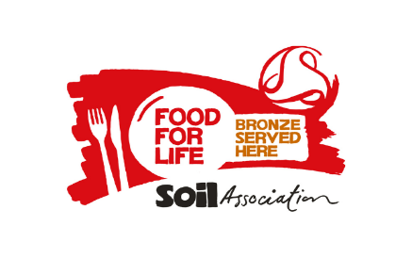
- All pupils can opt for Homemade soup instead of a pudding on any day
- Each plate will be served with the correct portion according to primary standards, plates will also contain all vegetables and carbs as specified on the menu.
- A seasonal salad bar is available to all pupils as well fruit even if they have pudding

Week commencing 28th August 25th September 6th November 4th December 2023 (15th January 2024)
Week 2 | Monday | Tuesday | Wednesday | Thursday | Friday
Option one | Orkney salmon and broccoli pasta | Sticky honey chicken with vegetable rice | Orkney mince and tatties | Roast chicken with roast potatoes gravy | BBQ sausages with rice
Information | All main courses come with 2 seasonal vegetables | All main courses come with two seasonal vegetables | All main courses come with two seasonal vegetables | Chicken can be served plain | Sausages can be served plain
Option two | Macaroni cheese | Singapore stir-fry vegetables and noodles | Vegetarian mince and tatties | Roasted Quorn fillet with gravy and roast potatoes | Hunters style vegetarian fillet with vegetable rice d
Information | We use Orkney cheddar | Our vegetables come from JW Gray ltd in Orkney | Wilson’s help us to source our Quorn mince | Fillet can be plain if required | Fillet can be plain if required
Option three | Homemade soup of the day. Egg mayonnaise sandwich | Homemade soup of the day. Cheese roll | Homemade soup of the day with a baked tattie topped with slow cooked pork casserole pork | Homemade soup of the day. Tuna mayonnaise sandwich | Homemade soup of the day. Ham and cheese baked tattie
Information | Sandwiches, rolls, wraps, baguettes come with soup and yoghurt / pudding | Sandwiches, rolls, wraps, baguettes come with soup and yoghurt / pudding | We always try and source Orkney tatties | Dolphin friendly and MSC certified | You can have ham or cheese or both today
Pudding | Golden acre yoghurt (various) or homemade apple crumble | Golden acre yoghurt (various) | Golden acre yoghurt (various) or homemade fruit flapjack | Golden acre yoghurt | Golden acre yoghurt (various)
Information
Fruit | Always available for all pupils additional to pudding | Always available for all pupils additional to pudding | Always available for all pupils additional to pudding | Always available for all pupils additional to pudding | Always available for all pupils additional to pudding
Medical Diet - if you have any medically certified dietary requirements, please contact the Head cook or School Admin
- All the meat we serve is responsibly sourced, we only use high welfare meats from Scotland and Orkney where at all possible
- All eggs used in school meals are free range and where possible sourced from Orkney
- Salad is always available for all pupils eating school dinner
- Each plate will be served with the correct portion according to primary standards, plates will also contain all vegetables and carbs as specified on the menu.
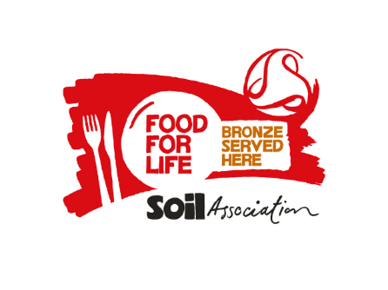

Weeks commencing 3rd September 2nd October 13th November 11th December 2023 (22nd January 2024)
Week 3 | Monday | Tuesday | Wednesday | Thursday | Friday
Option one | Sausage roll, with seasonal vegetables and baked beans | lasagna | Homemade chicken goujons, chips | Sweet and sour pork, savory rice | Orkney Breaded / battered haddock, potato wedges, peas
Information | From Williamson's butchers | Made with Orkney beef | Homemade and not processed | Pork can be served plain | Fish from Orkney fisherman’s society
Option two | Cheese and tomato pastry | Vegetable lasagna | Fishless fingers, chips, and peas | Lentil and vegetable hotpot with savory rice | Homemade cheese and onion quiche
Information | All main courses come with 2 seasonal vegetables | With lentil power | Main courses come with 2 seasonal vegetables | Packed full of goodness | With free range eggs and Orkney cheddar
Option three | Homemade soup of the day. egg mayonnaise | Homemade soup of the day. ham baguette | Homemade soup of the day. Baked tattie with sliced sausage and beans | Homemade soup of the day. Ham sandwich | Homemade soup of the day. Orkney cheese roll
Information | With free range eggs | Sandwiches, rolls, wraps, baguettes come with soup and yoghurt / pudding | Dolphin friendly and MSC approved | Tatties are from Orkney whenever possible | Add salad from our salad bar to your roll
Pudding | Golden acre yoghurt (various) | Golden acre yoghurt (various) or banana custard | Golden acre yoghurt (various) or homemade chocolate shortbread | Golden acre yoghurt (various) or Angel delight | Golden acre yoghurt (various)
 |  |  | made using Beremeal
Fruit | Always available for all pupils additional to pudding | Always available for all pupils additional to pudding | Always available for all pupils additional to pudding | Always available for all pupils additional to pudding | Always available for all pupils additional to pudding
Medical Diet - if you have any medically certified dietary requirements, please contact the Head cook or School Admin
- Please check your allergen sheet also attached for details of any allergens contained within our primary meals
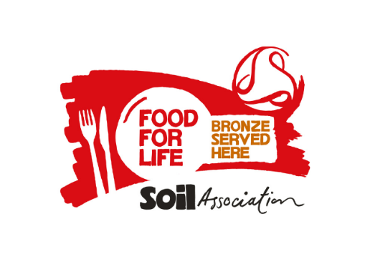
- All meals are served with the carb option of the day and two vegetables as well as a salad bar offering
- Each plate will be served with the correct portion according to primary standards, plates will also contain all vegetables and carbs as specified on the menu.

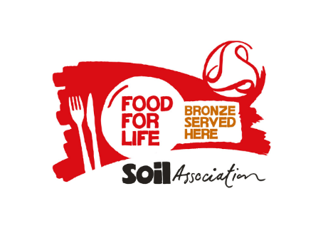
Week commencing 11th September 9th October 20th November 18th December 2023 (29th January 2024)
Week 4 | Monday | Tuesday | Wednesday | Thursday | Friday
Option one | Chicken fajitas wrap vegetable cous cous | Ham burger in a roll, potato wedges | Italian chicken pasta | Roast beef and Yorkshire pudding, roast potatoes | Fish goujons with chips, peas
Information | Can be served plain if needed | From Williamson’s butchers | Red tractor chicken breast | Tatties are from Orkney whenever possible | Orkney fish certified by MSC (Marine Stewardship council)
Option two | Coronation chickpea wrap vegetable cous cous | lentil patty, potato wedges | Tomato pasta bake | Cheese and lentil roast, Yorkshire pudding, roast potatoes | Broccoli and sweetcorn quiche
Information | Very mild, but full of flavour | Homemade | Full of vegetable goodness | All homemade | Made with free range eggs and Orkney cheddar
Option three | Homemade soup of the day, baked tattie with cheese and / or baked beans | Homemade soup of the day, Ham roll | Homemade soup of the day Turkey sandwich | Homemade soup of the day Baked tattie with Orkney mince | Homemade soup of the day. Chicken and mayonnaise baguette
Information | Orkney Cheddar | Sandwiches, rolls, wraps, baguettes come with soup and yoghurt / pudding | Red tractor Turkey breast | Williamson's ham and Orkney cheddar | Red tractor chicken breast
Pudding | Golden acre yoghurt (various) | Golden acre yoghurt (various) or homemade custard cream | Golden acre yoghurt (various) or Apple and Oat pudding | Golden acre yoghurt (various) or Fresh fruit jelly | Golden acre yoghurt (various)
 |  |  |  | made with vegetarian jelly
Fruit | Always available for all pupils additional to pudding | Always available for all pupils additional to pudding | Always available for all pupils additional to pudding | Always available for all pupils additional to pudding | Always available for all pupils additional to pudding
Medical Diet - if you have any medically certified dietary requirements, please contact the Head cook or School Admin
- Each plate will be served with the correct portion according to primary standards, plates will also contain all vegetables and carbs as specified on the menu.

